DAY 8 – 18.04.2024

ASSIGNMENT SCREENSHOTS

DEPARTMENT BUSINESS LOGIC OUTPUTS:

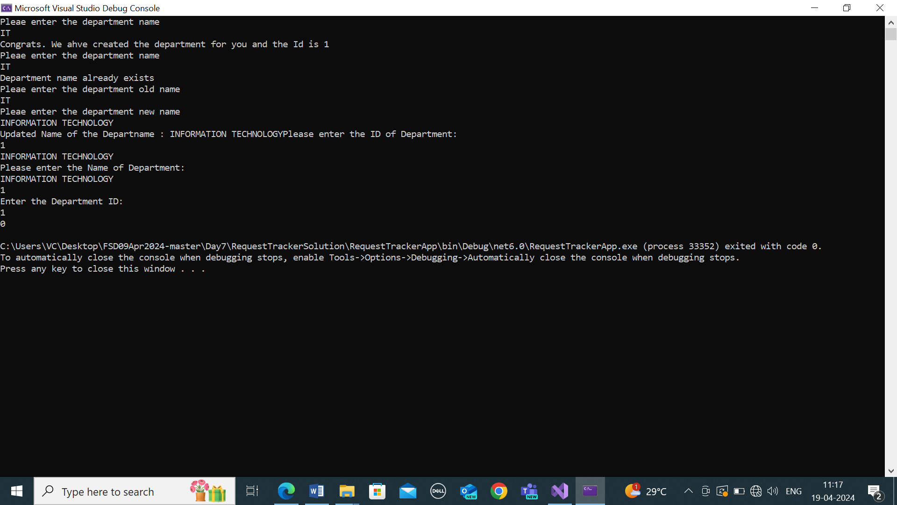

EMPLOYEE LOGIC OUTPUT SCREENSHOTS:

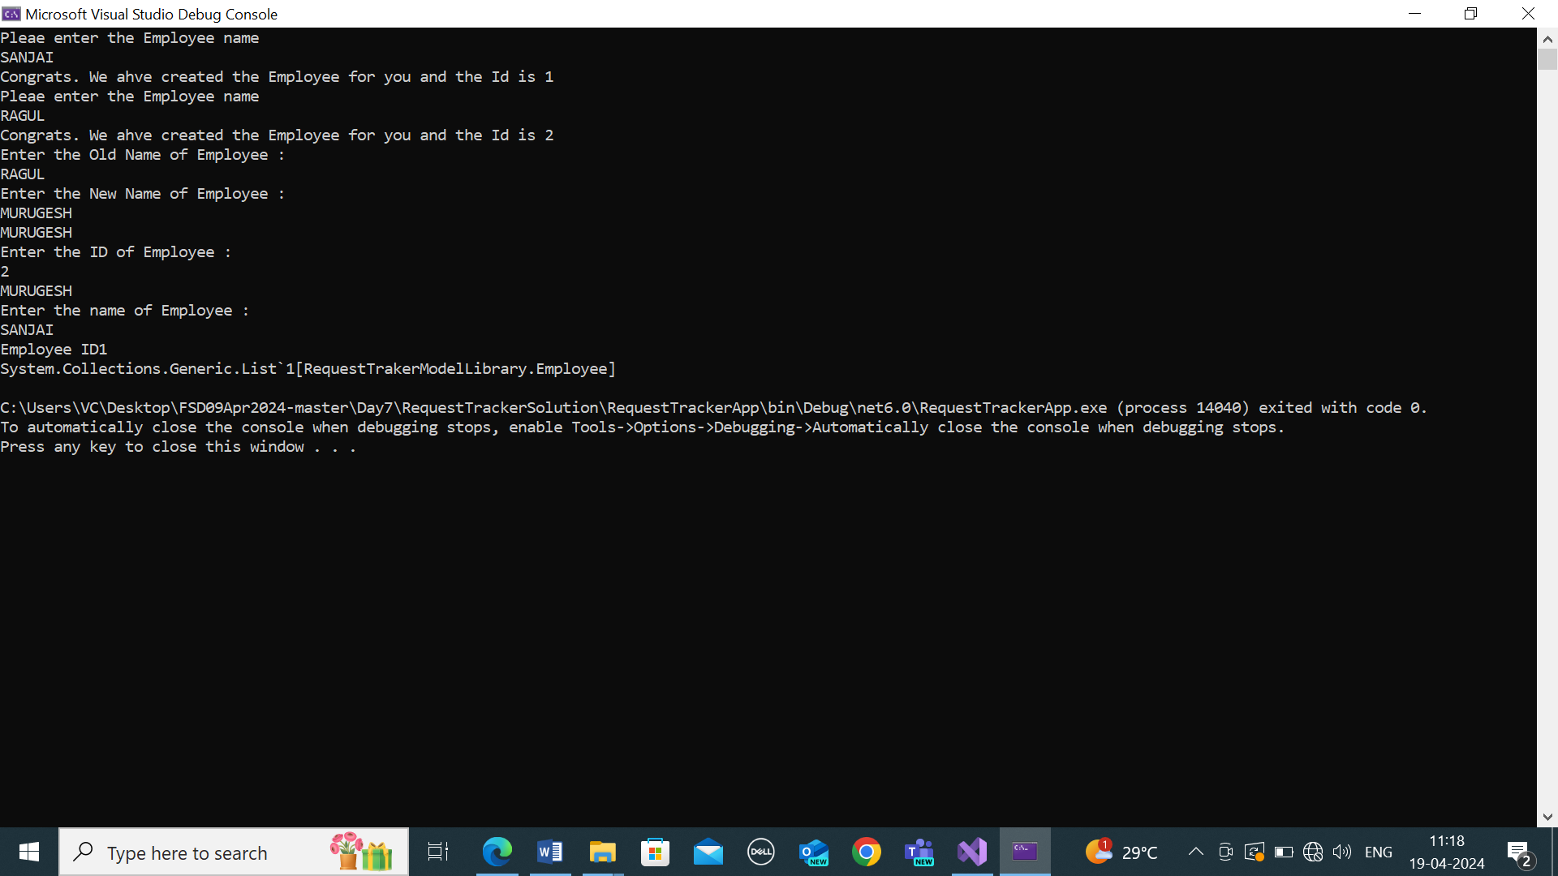

AFTERNOON SESSION:

UNDERSTANDING INDEXER:

